**Commodore PET IEEE-488 Extender Base Board Rev. 0**

**Testing**

# Setup

The tests were conducted with a CBM8032 computer, a CBM8050 Floppy Disk Drive, an SD2PET future and a DIY ribbon cable (appr. 1 meter long). Further, a C64 with an IEEE-488 interface was used

# Test Execution

## Direct SD2PET

The SD2PET future was connected to the Base Board, which was then connected to the IEEE-488 port of the CBM8032.

The SD2PET could be accessed without a problem.

## CBM8050 via ribbon cable

The CBM8050 was connected via the base board and the ribbon cable. The 8050 could be accessed.

## CBM8050 via ribbon cable to IEEE488 interface and a C64

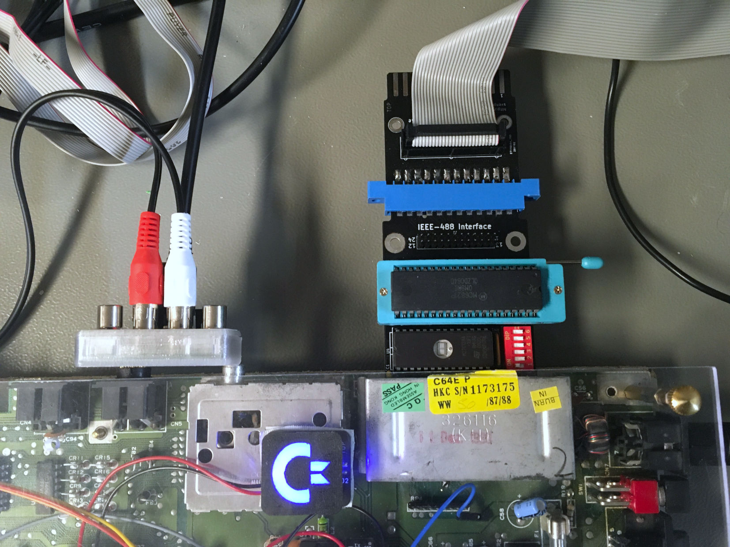

Figure 1: Test with C64 an IEEE-488 interface and a CBM8050

The CBM8050 could be accessed via the shown configuration. The result was not perfect, though. It is not determined, if this is matter of the interface or the ribbon cable.

# Conclusion

The PET IEEE-488 Expender Base Board Rev. 0 is functional.